EXPERIMENT NO. 15

Git Branching and Merge Conflict Resolution

Aim
To demonstrate the use of Git branches and resolve merge conflicts while collaborating on a shared GitHub repository.

Software Requirements
- Windows 10/11 (or Linux/macOS)
- Git
- GitHub Account
- Visual Studio Code (or any code editor)
- Web Browser
- Internet Connection

Theory
Git branching allows developers to work on different features independently without affecting the main project. A merge conflict occurs when two branches modify the same part of a file and Git cannot automatically decide which change to keep. Conflicts are resolved by manually editing the affected files, marking them as resolved, and committing the merged changes. This process ensures smooth collaboration among multiple developers.

Procedure
Step 1: Clone the Shared Repository
Open Git Bash or Terminal.
git clone https://github.com/Organization/RepositoryName.git

Move to the project folder.
cd RepositoryName

Step 2: Create a New Branch
Create and switch to a new branch.
git checkout -b feature-update

Verify the current branch.
git branch

Step 3: Make Changes
- Open the project in Visual Studio Code.
- Modify a file (for example, update the README or edit a function).
- Save the changes.
Step 4: Commit the Changes
Check the repository status.
git status

Stage the changes.
git add .

Commit the changes.
git commit -m "Updated README and added new changes"

Step 5: Push the Branch
git push origin feature-update

Step 6: Pull the Latest Changes from Main Branch
Switch to the main branch.
git checkout main

Download the latest changes.
git pull origin main

Step 7: Switch Back to Feature Branch
git checkout feature-update

Step 8: Merge Main into Feature Branch
git merge main

If no conflicts occur, Git merges automatically. If conflicts occur, Git displays a merge conflict message.
Step 9: Resolve Merge Conflicts
- Open the conflicting file.
- Locate the conflict markers.
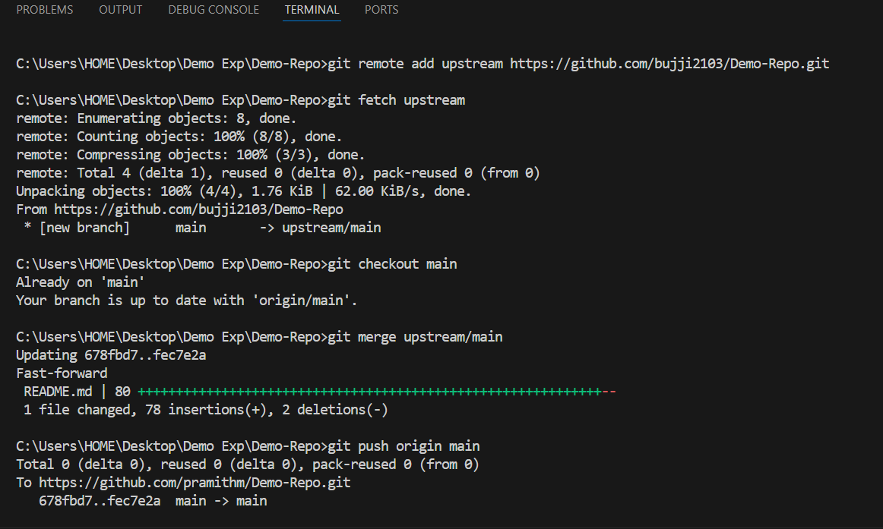
Example:
<<<<<<< HEAD
My changes
=======
Main branch changes
>>>>>>> main

- Edit the file by keeping the correct content.
- Remove the conflict markers.
- Save the file.
Mark the conflict as resolved.
git add .

Step 10: Commit the Merge
git commit -m "Resolved merge conflicts"

Step 11: Push the Updated Branch
git push origin feature-update

Go to GitHub.
- Open the repository.
- Click Compare & Pull Request.
- Review the changes.
- Click Create Pull Request.
Step 12: Merge the Pull Request
- Review the Pull Request.
- Click Merge Pull Request.
- Confirm the merge.

Screenshots
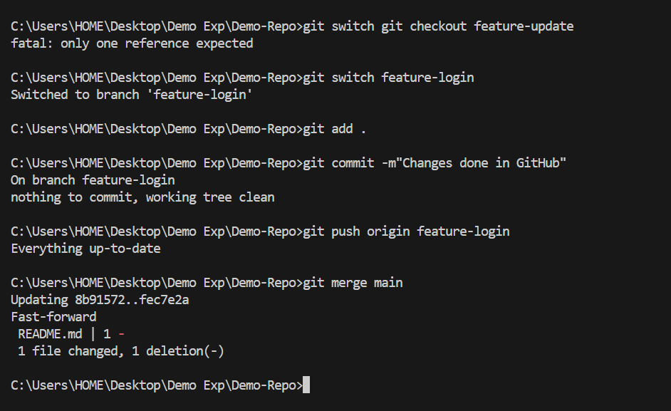

Observation
- The repository was cloned successfully.
- A new branch was created for development.
- Changes were committed and pushed to GitHub.
- The latest changes from the main branch were merged.
- Merge conflicts were resolved manually.
- The updated branch was pushed successfully.
- A Pull Request was created and merged.

Result
The Git branching and merge conflict resolution process was successfully completed. The feature branch was updated with the latest changes from the main branch, merge conflicts were resolved manually, and the final changes were pushed and merged using a Pull Request.

